Sea Lion Australian sea lion

***Neophoca cinerea* — Australian Sea-lion**

<http://www.environment.gov.au/cgi-bin/sprat/public/publicspecies.pl?taxon_id=22>

Australian Sea-lions feed on a wide variety of prey, including cephalopods, fish, sharks, rock lobsters and sea birds (Gales & Cheal 1992; Ling 1992). There is little quantitative information on their diet as only a few hard parts are normally found in the faeces of this species (Gales & Cheal 1992), although the species is known to 'feed' at fishing boats on scraps or by taking fish off lines. Australian Sea-lions in western WA spend more time foraging compared to those in SA due to the less productive conditions of the Leeuwin Current (Lowther et al. 2013).

Radio transmitter and time-depth recorder studies of Australian Sea-lions at Seal Bay found that nursing females were benthic feeders on the continental shelf approximately 20–30 km offshore, in depths less than 150 m (Costa et al. 1988, 1990). While at sea, females and juveniles dive almost continually through the day and night. Young sea lions (approximately 7–18 months old) have been recorded foraging in depths up to 60 m and range up to 10 km from their birth colony (Fowler & Costa 2004 cited in Campbell 2005). Less is known about males’ feeding behaviour, but they are recorded to dive deeper.

Squid beaks were found in 87% of scats, All scats contained fish scales, sea mullet scales, Qualitatively, these data indicate that N. ***cinerea*** has a varied diet consisting of teleost

fish, cephalopods of three families, one species of elasmobranch, lobster and one species

of bird. Bones, skin and feathers of penguins are commonly found in sea-lion colonies. The feather from the scat in this study is therefore perhaps from a little penguin ***(E.*** minor).

The cephalopods, elasmobranch and lobster are all benthic organisms, indicating that

N. cinerea forages benthically. Otoliths were not assigned to fish species, so the position of

the fish in the water column is unknown. Walker and Ling (1981) and Ling (1992) summarised anecdotal accounts of sea-lions feeding on whiting (Silliganodes punctata), salmon (Arripis trutta), school shark (Galeorhinus galeus), gummy shark (Mustelus antarcticus), little penguin (Eudyptula minor), lobster (Jasus sp.) and cuttlefish (Sepia sp.). Sea-lions have been observed taking the livers from school sharks caught in nets (Inns et al. 1979) and feeding on green turtles (Chelonia mydas) (G. Mercer, personal communication).

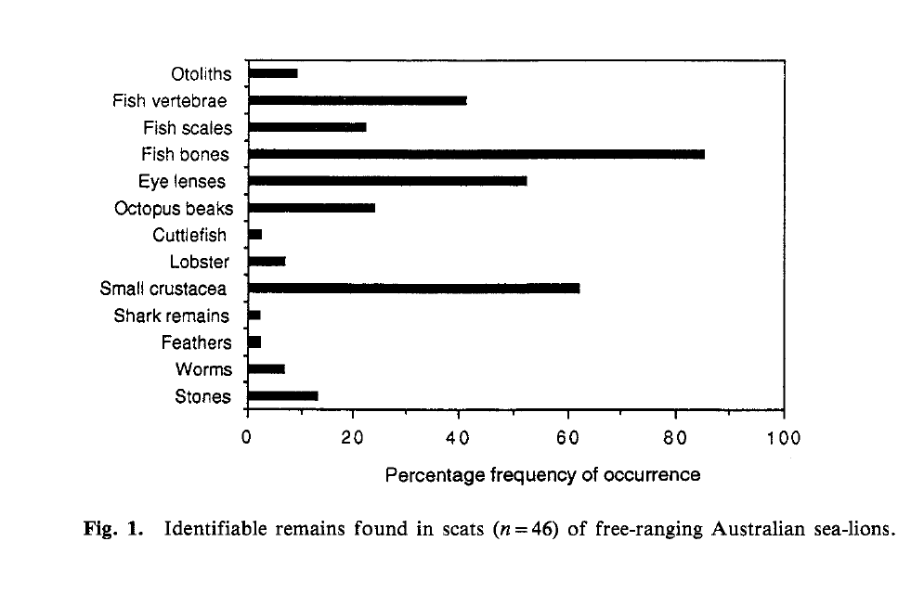

from Gales and Cheal, 1992

|  |  |
| --- | --- |
| **prey item** | **probability of consuming** |
| LOB Lobster adult | 0.1 |
| LOJ Lobster juvenile | 0.1 |
| CEP Cephalopod | 0.2 |
| SBP Penguin | 0.2 |
| FDC demersal shallow carnivore | 0.2 |
| FDO demersal shallow omnivore | 0.2 |
| FMA demersal macroalgal feeder | 0.2 |
| SD shark demersal | 0.3 |
| MAZ Macrozoobenthos crabs | 0.1 |

References:

Gales, N.J. & Cheal, A.J. (1992). Estimating diet composition of the Australian sea-lion *(Neophoca cinerea)* from scat analysis: an unreliable technique. *Wildlife Research*. 19:447-456.

Ling, J.K. (1992). Neophoca cinerea. *Mammalian Species*. 392:1-7.

Lowther, A.D., R.G. Harcourt & S.D. Goldsworthy (2013). Regional variation in trophic ecology of adult female Australian sea lions inferred from stable isotopes in whiskers. *Wildlife Research*. 40:303-311.

Walker, G. E., and Ling, J. K. (1981). Australian seal lion ***Neophoca cinerea*** (Peron, 1816). In 'Handbook of Marine Mammals, Vol. 1'. (Eds S. H. Ridgway and R. J. Harrison.) pp. 99-118. (Academic Press: New York.)